Q1.

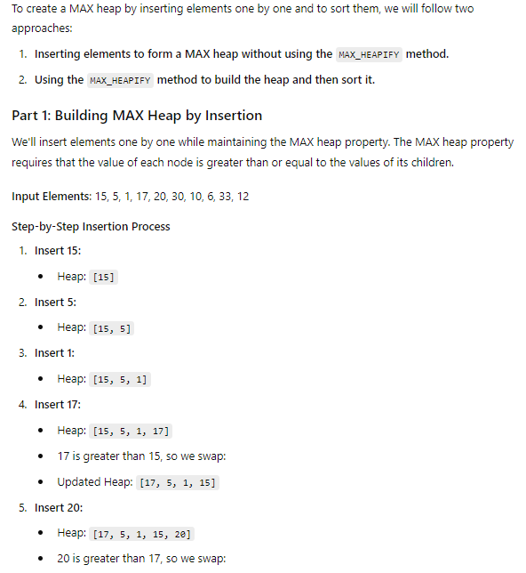

Q3.  
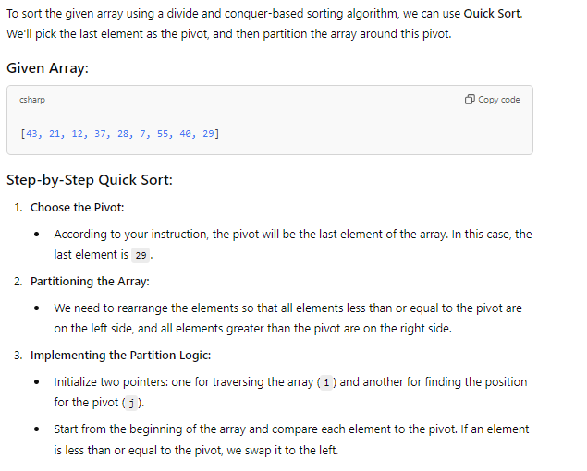

Q4.

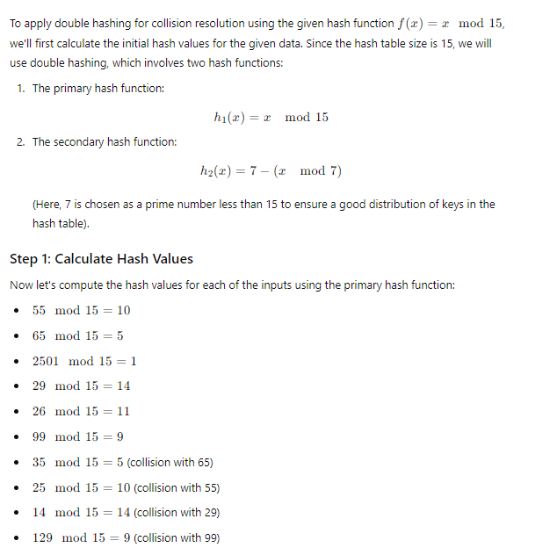

Q.5A.



